**DAY 1: Assignment – 1 &2**

**Assignment 1:**

**1. Write some network terminology:**

Here are some network terminologies

**1. IP Address (Internet Protocol Address) :** A unique string of numbers separated by periods (IPv4) or colons (IPv6) that identifies each computer using the Internet Protocol to communicate over a network.

**2. MAC Address (Media Access Control Address) :** A hardware identification number that uniquely identifies each device on a network. It is assigned to the network interface card (NIC) by the manufacturer.

**3. Router :** A device that forwards data packets between computer networks, creating an overlay internetwork. Routers perform the traffic directing functions on the Internet.

**4. Switch :** A device that connects devices within a network and uses packet switching to forward data to its destination within the network.

**5. Firewall :** A network security system that monitors and controls incoming and outgoing network traffic based on predetermined security rules.

**6. VPN (Virtual Private Network) :** A service that allows you to connect to the internet via a server run by a VPN provider. All data traveling between your computer, smartphone or tablet, and this VPN server is securely encrypted.

**7. DNS (Domain Name System) :** The phonebook of the Internet, translating domain names to IP addresses so browsers can load Internet resources.

**8. Bandwidth :** The maximum rate of data transfer across a given path. It is typically measured in bits per second (bps).

**9. Protocol :** A set of rules governing the exchange or transmission of data between devices.

**10. TCP/IP (Transmission Control Protocol/Internet Protocol) :** A suite of communication protocols used to interconnect network devices on the internet. TCP and IP are the two main protocols, with IP being responsible for addressing and routing packets of data.

**11. NAT (Network Address Translation) :** A method of remapping one IP address space into another by modifying network address information in the IP header of packets while they are in transit across a traffic routing device.

**12. SSID (Service Set Identifier) :** The name of a Wi-Fi network. When you set up a wireless home network, you give it a name to distinguish it from other networks in your area.

**13. LAN (Local Area Network) :** A network that connects computers within a limited area such as a residence, school, laboratory, or office building.

**14. WAN (Wide Area Network) :** A telecommunications network that extends over a large geographical area for the primary purpose of computer networking.

**15. Packet :**  A small segment of data that is bundled for transmission over a network. Each packet contains part of the message being sent and information about its destination.

**16. Ethernet :** A family of computer networking technologies commonly used in local area networks (LAN), metropolitan area networks (MAN), and wide area networks (WAN).

**17. Gateway :** A network node that connects two different networks using different protocols, allowing them to communicate with each other.

**18. Proxy Server :** A server application or appliance that acts as an intermediary for requests from clients seeking resources from other servers.

**19. Load Balancer :** A device that distributes network or application traffic across a number of servers to ensure no single server becomes overwhelmed and to optimize performance and reliability.

**20. QoS (Quality of Service) :** A feature of routers and switches which prioritizes traffic so that more important traffic can pass first.

--------------------------------------------------------------------------------------------------------------------------

**Assignment – 2**

**Draw your Home Network Topology and explain how you are accessing the RPS Lab environment.**

**Home Network Topology :**

**Diagram:**

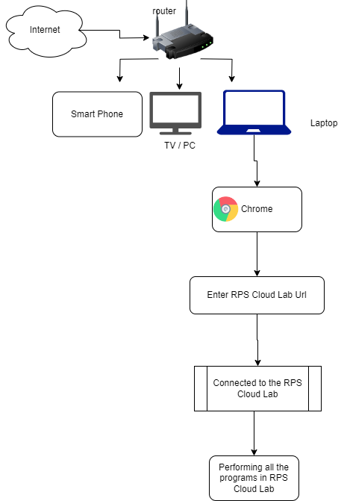

- Internet → Router → Devices (Smartphone, Computer/PC, Laptop)

**1. Internet :** This is the external network that provides connectivity to your home network.

**2. Router :** The router is the gateway that connects your home network to the internet. It routes traffic between your devices and the external network.

**3. Devices :**

- Smartphone

- Computer/PC

- Laptop

These devices are connected to the router, either via Wi-Fi or Ethernet, enabling them to access the internet.

**4. Web Browser (Chrome):** This is the application used on the devices to access web resources. You use Google Chrome to access the RPS Cloud Lab.

**5. Accessing RPS Cloud Lab :**

- Entering RPS Cloud Lab URL : You open Chrome and enter the URL for the RPS Cloud Lab.

- Connecting to RPS Cloud Lab : After entering the URL, your device establishes a connection with the RPS Cloud Lab server over the internet.

**6. Using RPS Cloud Lab :**

- Once connected, you perform all necessary programs and tasks within the RPS Cloud Lab environment.

**Accessing RPS Cloud Lab :**

- On any device, open Chrome

- Enter the RPS Cloud Lab URL

- Connect to the RPS Cloud Lab

- Perform tasks in the RPS Cloud Lab environment